
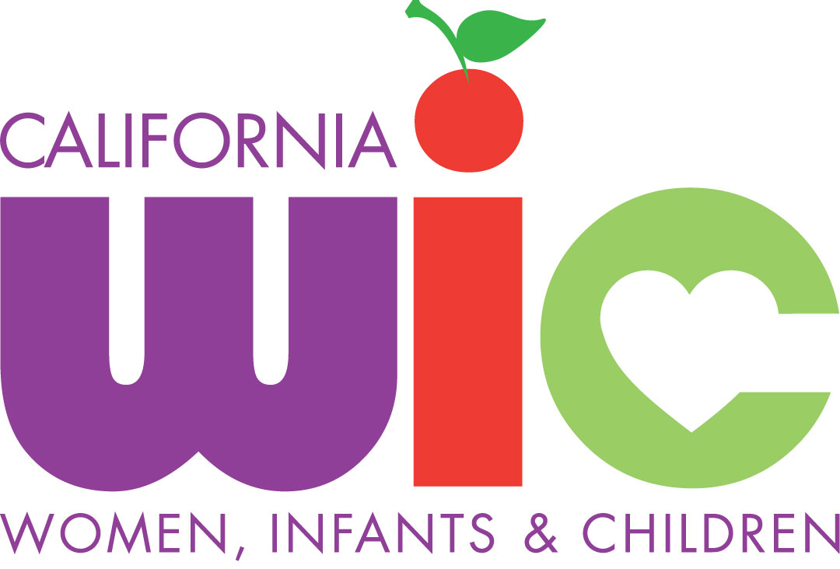

UHC WIC Program
External Job Announcement

(Open until filled)

Position Title: Regional Breastfeeding Liaison (Full-time)
Summary of This non-exempt position reports to the Breastfeeding Education Coordinator.
Position: The Regional Breastfeeding Liaison (RBL) responsibilities are to conduct the outreach and networking efforts in the Fresno County and Madera County communities as a whole (e.g., doctors, CPSP, hospitals, employers, etc.) in order to promote breastfeeding. This position is responsible for the effective marketing of the Central Valley WIC Programs’ breastfeeding education and support services, through effective communication that includes the use of verbal skills and the development and distributing of various WIC breastfeeding education and outreach materials for public view as well as for general outreach activities. Is expected to generate written correspondence, calendar events, develop general articles and reports as necessary, with minimal supervision, in the management of the Regional Breastfeeding Liaison Project’s goals and objectives.
Education: - Completion of an internship accredited by Academy of Nutrition & Dietetics (AND);
and certified as a Registered Dietitian (RD) or Registered Dietitian Nutritionist (RDN) through the Commission on Dietetic Registration (CDR) or certified within 18 months of employment, or

- BA or BS in Communication, Marketing, Public Relations, Health Sciences
and/or related field from an accredited college or university. Minimum 2 years of experience in outreach and/or public relations. Ideally, familiarity with healthcare industry, health issues, and/or community advocacy.

License/ - Possess a valid Commission on Dietetic Registration, preferred.
Certification: - International Board Certified Lactation Consultant (IBCLC) or Certified Lactation
Counselor (CLC) or Certified Lactation Educator (C.L.E.) preferred or certified
within 18 months of employment.
- Valid CA Driver's License required
Location: Tarpey WIC Site
Application Procedure: Go to, https://nonprovider-unitedhealthcenters.icims.com/jobs/1277/wic-regional-breastfeeding-liaison/job , apply on-line.
United Health Centers of San Joaquin Valley
WIC Administration
Attn: Denise Lee-Martinez
650 Zediker Ave Bld#2
Parlier CA 93648
(559) 638-3948; FAX (559) 646-6998
Email: leed@unitedhealthcenters.org

“This institution is an equal opportunity provider”
“In accordance with Federal law and U.S. Department of Agriculture policy, this institution is prohibited from discriminating on the basis of race, color, national origin, sex, age, or disability. To file a complaint of discrimination, write USDA, Director, Office of Civil Rights, 1400 Independence Avenue, SW, Washington, DC 20250-9410 or Call (800) 795-3272 (voice) or (202) 720-6382 (TTY). USDA is an equal opportunity provider and employer.”
“In accordance with Federal law and U.S. Department of Agriculture policy, this institution is prohibited from discriminating on the basis of race, color, national origin, sex, age, or disability. To file a complaint of discrimination, write USDA, Director, Office of Civil Rights, 1400 Independence Avenue, SW, Washington, DC 20250-9410 or Call (800) 795-3272 (voice) or (202) 720-6382 (TTY). USDA is an equal opportunity provider and employer.”

