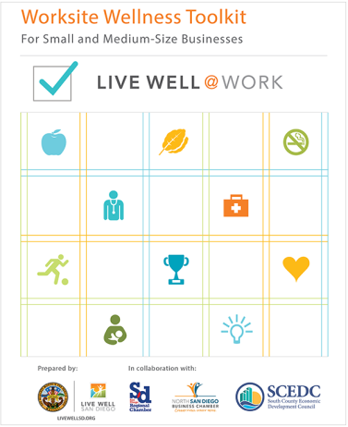
WORKSITE WELLNESS TOOLKIT - WORKSHEET
This worksheet outlines a simple framework with four components for worksite wellness: Plan, Do, Act, Assess.
This evidence-based framework includes the key elements found across the literature for developing healthy workplaces. These are the necessary steps needed to support efforts to successfully plan, develop, implement and reassess worksite wellness strategies. This information can be used to complete page 2.
PLAN
1
- How can you assess the needs of your employees?
- Who can champion your wellness efforts?
      - How can you get support from your upper management?

_____________________________________________________________________________________
_____________________________________________________________________________________
_____________________________________________________________________________________
- How can you communicate your worksite wellness vision to your employees?
- How do you prioritize your wellness goals and objectives?
DO
2

_____________________________________________________________________________________
_____________________________________________________________________________________
_____________________________________________________________________________________
- What ideas did you learn about designing and implementing wellness programs?
      - What types of incentives would you provide your employees?

ACT
3

_____________________________________________________________________________________
_____________________________________________________________________________________
_____________________________________________________________________________________
4
ASSESS
- How will you measure success?
      - How can you continue your worksite wellness program?

_____________________________________________________________________________________
_____________________________________________________________________________________
_____________________________________________________________________________________
Make a Commitment Today
Consider the ideas you wrote down on page 1. Select one action you can begin at your worksite.

PLAN
- Identify one thing you can start doing in your workplace tomorrow.
_____________________________________________________________________________________
_____________________________________________________________________________________
DO

- What step is most needed to make it happen?

_____________________________________________________________________________________
_____________________________________________________________________________________
ACT

- What activity or program will you implement?
_____________________________________________________________________________________
_____________________________________________________________________________________
ASSESS

- How will you measure success?
_____________________________________________________________________________________
_____________________________________________________________________________________

For additional tools please visit livewellsd.org/worksite-wellness-toolkit

