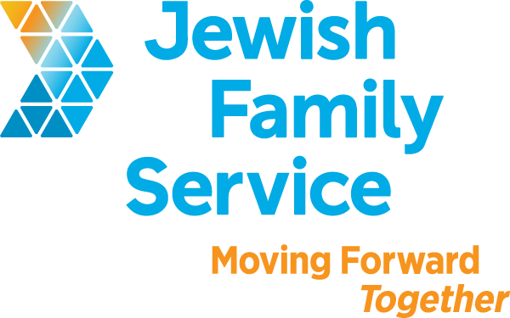
Emergency Planning Workshops:
Family Preparedness

With immigration enforcement on the rise, undocumented and other immigrants living in the U.S. are increasingly at risk of detention and deportation. We encourage families to prepare for the possibility of being separated from one another by planning for childcare and their financial assets. While it is our hope that no one must use their plan, our workshops help guide you through these important decisions and the specific ways to prepare for the worst.
FREE and Open to the Public
Language: Spanish/English
Capacity: 10 people per session
We can come to you! To schedule a workshop for your community, please call (858) 637-3026 or email immigration@jfssd.org

