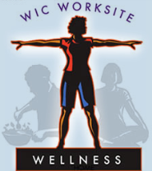 WIC Worksite Wellness Program Commitment Form

I, , on behalf of

Local Agency, recognize the value of our Local Agency and its offices becoming a Certified Well WIC Worksite. Our Agency will follow the “Ten Steps” guidelines and criteria to make health and wellness a part of the Agency’s work culture. Our Agency will actively support employees in activities that foster and maintain all-around health and create a health-promoting environment. We promise to use imagination to propose healthful activities, solicit ideas from our staff, and encourage a dialogue that will promote well-being among all staff. I further promise to create and work toward my own set of wellness goals and to support my fellow employees as they work toward their own goals. I understand that our agency has 18 months to become a Certified Well WIC Worksite.

Signed: Date:

Name:

Address:

Telephone:

Email:

FAX:

Please send your completed form to:
WIC Worksite Wellness Program
California WIC Association
3120 Freeboard Dr. #101
West Sacramento, CA 95691
jmulliganpfile@calwic.org or fax 916.572.0760

Congratulations on taking the first step toward becoming a Certified Well WIC Worksite!

11/04/2019

