CD11 – Mark DeSaulnier
WIC Agency | WIC Participants Served/District | Est. $ Into local economy  (per month)
Contra Costa County WIC Program  WIC Program Director  Raz Moghbel  (925) 646-5067 | 11,192 | $885,818.75 | 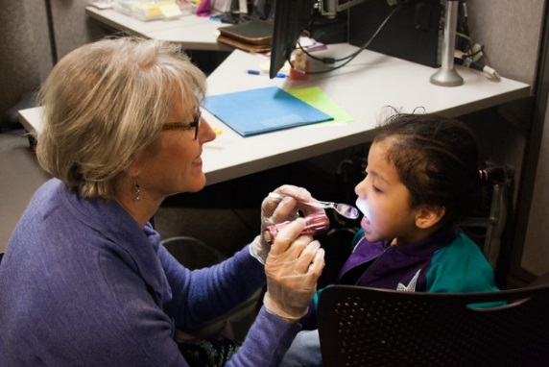  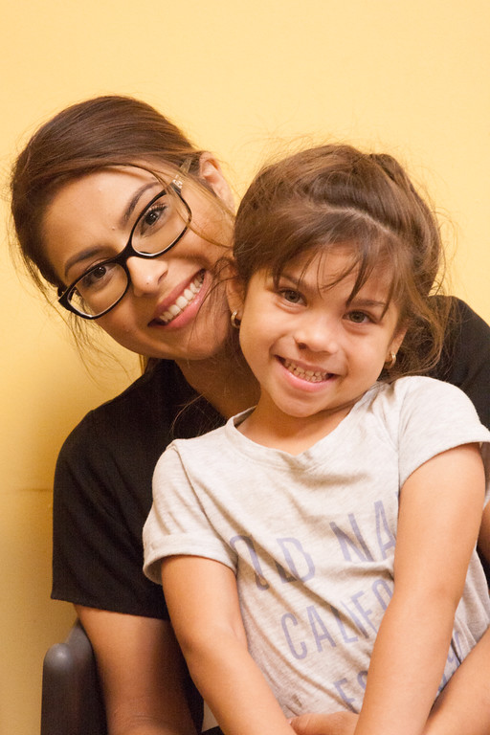  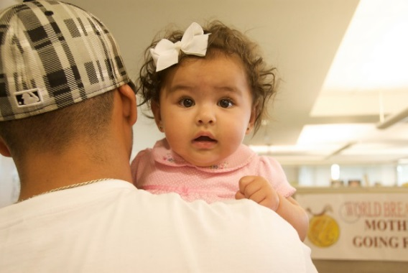

The count of WIC participants reflects May 2019 using home address. WIC purchases are those for May 2019 using store address.

